Where can I download the 2010 NED data via ftp?

NED data files can be accessed and downloaded using either an FTP client or through the web browser. The directions as how to gain access is provided below.

Web Browser

Visit this site: ftp://atlas.ca.gov/pub/ned/ to download the information you are searching for.

FTP Client

Client used in the screenshots below is Filezilla version 3.5.2

The information that needs to be in your Site Manager is as follows:

Host: projects.atlas.ca.gov
Protocol: FTP
Encryption: Use plain FTP
Logon Type Anonymous

Once you have logged in select the PUB folder and scroll down the list until you find NED. Open the NED folder and select what you would like to transfer.

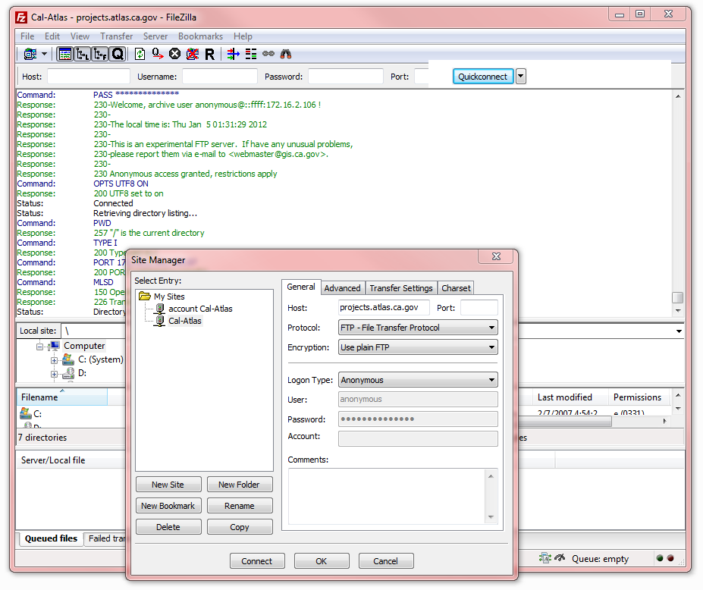

If any anomalies occur please contact monica.markel@resources.ca.gov

Thank you and have a wonderful 2012!

