**Mosaic C and F**

Due to the size of mosaics C and F we had to place it on our FTP site. It can be easily downloaded as an anonymous user.

If you do not have an FTP client then you must install one. We happen to use FileZilla because it is free. (<http://filezilla-project.org>)

Once you have an FTP application you will need to fill in the following:

**Host-** Projects.atlas.ca.gov

**Protocol-** FTP File Transfer Protocol

**Encryption –** Use plain FTP

Then select connect.

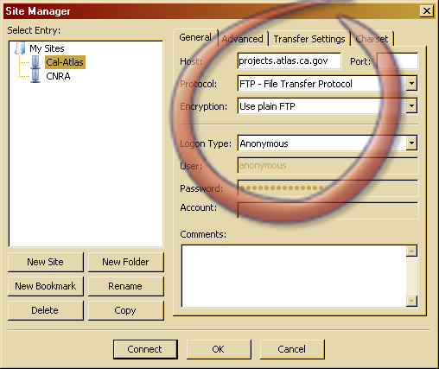

You should see a tree that looks like this…

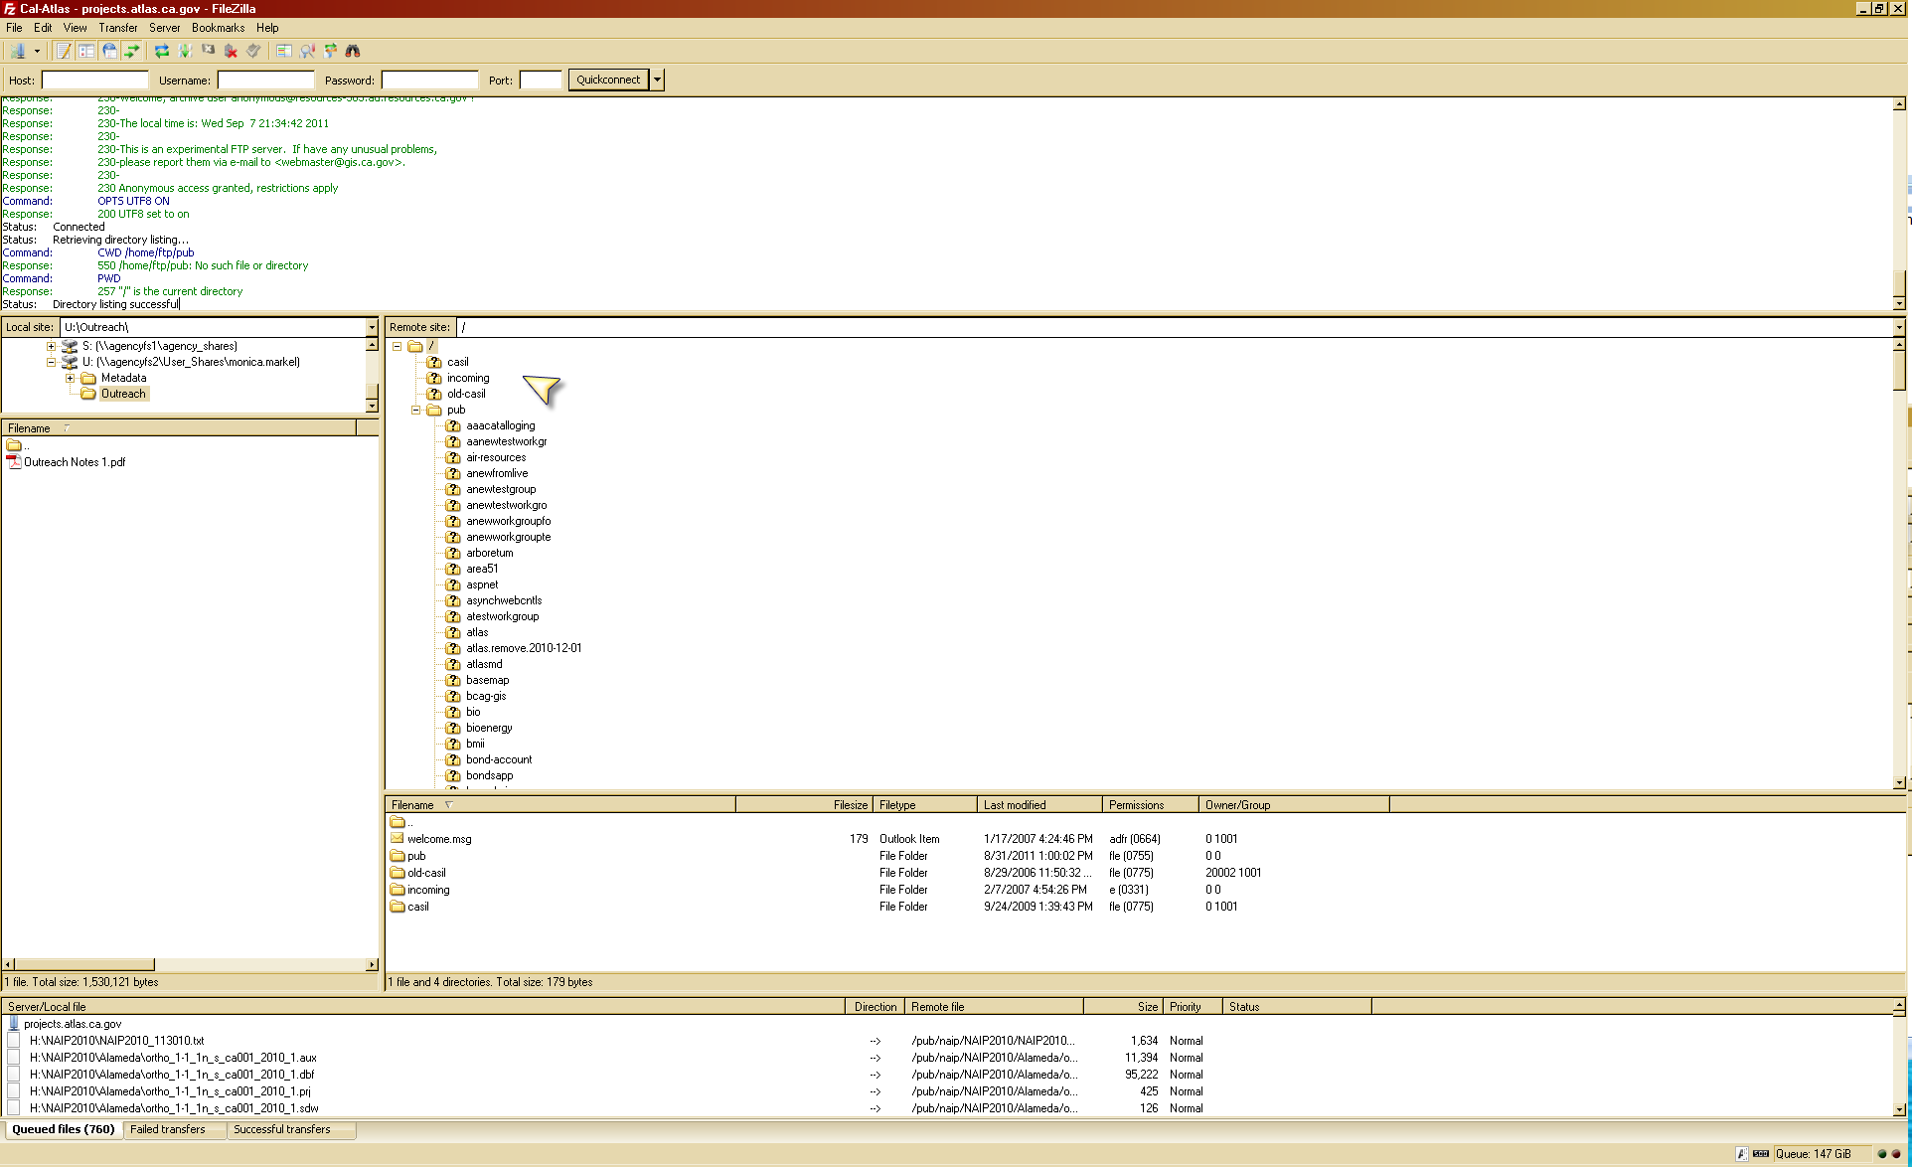

In the **Pub folder** you will need to scroll down to find **photo1970** as seen below. Then within the next directory you will be able to find the imagery to download.

