ADS-40 Digital Imagery Acquisition
of

San Francisco-Oakland, California



ADS40 Imagery Collection Project

San Francisco, CA

Earthdata International of Maryland, Inc requested the collection of ADS-40 imagery data over San Francisco, CA. The data was collected to support the generation of color ortho-photographs with a 0.3 meter ground sample distance (GSD). In response EarthData Aviation acquired image data between October 20th, 2003 and January 21, 2004 using its Navajo Chieftain aircraft with tail number N76JN. Image data was captured using a Leica ADS40 camera system, including an inertial measuring unit (IMU) and a dual frequency GPS receiver.

GPS Data Collection

During airborne data collection, an additional GPS receiver was in constant operation over a published National Geodetic Survey (NGS) control point at Livermore Municipal Airport. The control point, designated “TOM L”, is a B order horizontal point with a second order class I ellipsoid height. During the data acquisition, the receivers collected phase data at an epoch rate of 1 Hz.

Station | NAD83 (1998) |  | Ellipsoid Hgt.
TOM L (PID AC6328) | N 37° 41’ 45.66198” | W 121° 49’ 08.94549” | 85.72 m
Coordinate position of the GPS base station

GPS Data Processing

All GPS phase data was post processed with continuous kinematic survey techniques using “On the Fly” (OTF) integer ambiguity resolution. The GPS data was processed with forward and reverse processing algorithms. The results from each process, using the data collected at the airport, were combined to yield a single fixed integer phase differential solution of the aircraft trajectory. Plots of altitude and the forward and reverse GPS solution residuals are attached. The difference between the forward to reverse solutions for each lift indicate valid and accurate solutions. These differences are summarized in the table below:

Lift | Date | Forward – Reverse Separations (meters)
Lift | Date | Horizontal Component | Vertical Component
1 | 10/20/2003 | 0.04 | 0.1
2 | 10/21/2003 | 0.08 | 0.16
3 | 10/23/2003 | 0.05 | 0.15
4 | 10/24/2003 | N/A ** | N/A **
5 | 10/25/2003 | 0.08 | 0.25
6 | 10/26/2003 | 0.08 | 0.18
7 | 10/27/2003 | 0.10 | 0.18
8 | 10/28/2003 | 0.08 | 0.14
9 | 11/12/2003 | 0.07 | 0.07
10 | 11/18/2003 | 0.05 | 0.11
11 | 11/21/2003 | 0.03 | 0.09
12 | 11/22/2003 | 0.07 | 0.10
13 | 11/23/2003 | 0.05 | 0.08
14 | 1/21/2004 | 0.05 | 0.08

** NOTE: The original processed forward solution did not compare well with the processed reverse solution in the vertical component (±0.35m). However, the fixed forward solution did agree well with the float solution. So, the decision was made to only use the forward solution. Therefore, separation plots are not available for this lift.

Orientation Data Processing

An IMU was used to record precise changes in position and orientation of the ADS-40 camera at a rate of 200 Hz. All IMU data was processed post flight with a Kalman filter to integrate inertial measurements and precise phase differential GPS positions. The resulting solution contains geodetic position, omega, phi, kappa, and time for subsequent merging with the laser ranging information.

ADS-40 Data Collection

The areas of interest were flown at an altitude of 2880 meters (9450 feet) above mean terrain. The ADS-40 collection specifications follow:

Sensor Collection Parameters
Flying Height | 9450 m AMT
Target Airspeed | 175 knots
Desired GSD | 0.30 meters
Camera Cycle Time | 3.0 ms
Collection Mode | Standard All

The table below summarizes the data collection by date:

Data Collection By Date
Lift | Date | Lines Collected
1 | 10/20/2003 | 19-26
2 | 10/21/2003 | 26-36
3 | 10/23/2003 | 19,36B 37C 14-18A
4 | 10/24/2003 | 2-14
5 | 10/25/2003 | 1-2A, 36-48C
6 | 10/26/2003 | 48-55C, 56-62D
7 | 10/27/2003 | 62-75
8 | 10/28/2003 | 75-89
9 | 11/12/2003 | 102-107
10 | 11/18/2003 | 94-102
11 | 11/21/2003 | 90-94, 107-110
12 | 11/22/2003 | 120-139
13 | 11/23/2003 | 108-120
14 | 1/21/2004 | 99-106

ADS-40 Data Quality Control

Prior to data delivery, the ADS-40 imagery was examined by EarthData Aviation to assure the data quality. This quality control check involved examining raw images from every array of the ADS-40 for every flight. These images were examined for any data anomalies that might occur such as pixel drop-outs. In addition to this check of the raw images, the nadir image from each flightline was rectified to a plane at a subsampled pixel resolution. These georeferenced images were imported into viewing software and then examined. The examination of the rectified images was used to identify any clouds, cloud shadows, data gaps, smoke, etc… Any possible issues that were identified during this QC were then addressed on a case-by-case basis and reflights were scheduled where applicable.
GPS Processing Graphs

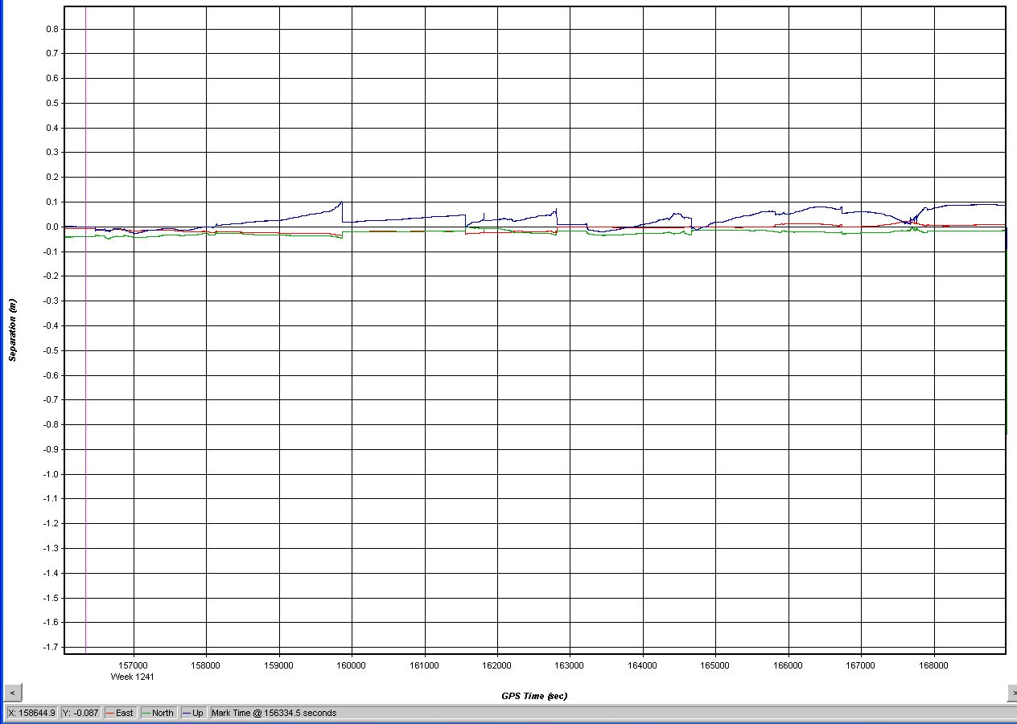
Forward-Reverse Solution Residuals
Lift 1: 20 October, 03

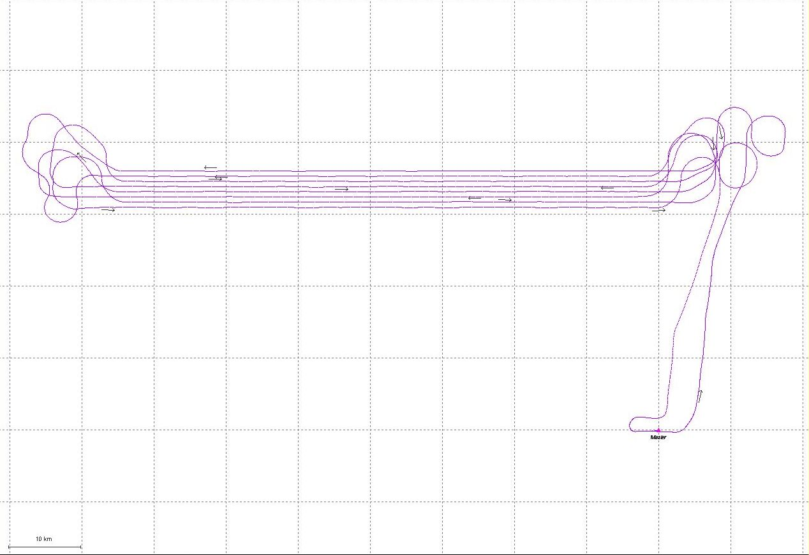
Aircraft Trajectory Plot
Lift 1: 20 October, 03

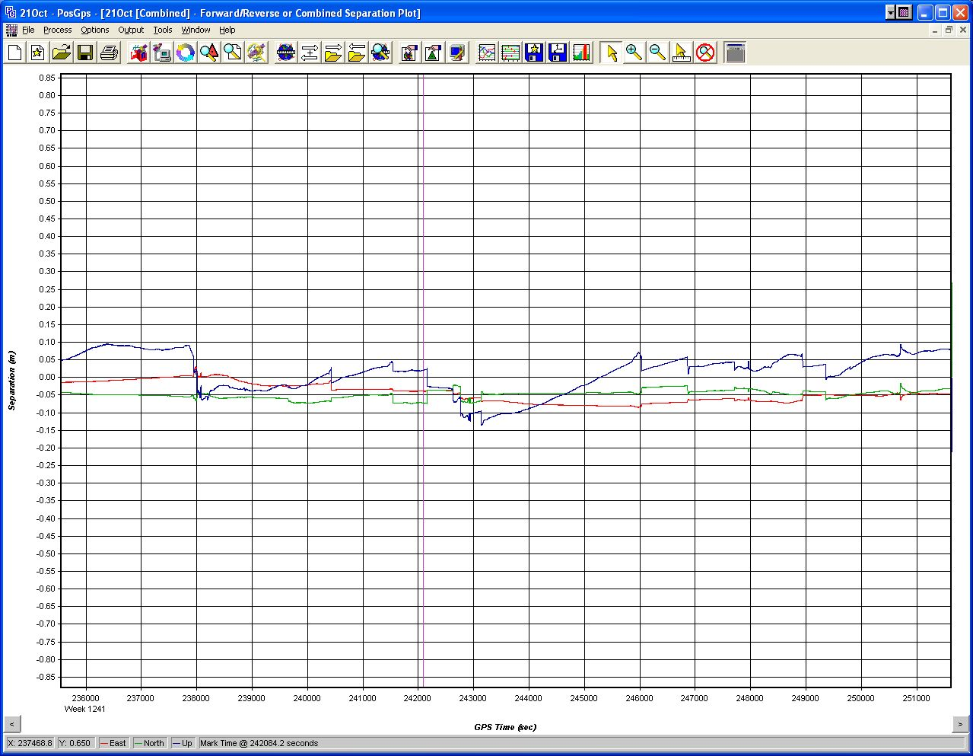
Forward-Reverse Solution Residuals
Lift 2: 21 October, 2003

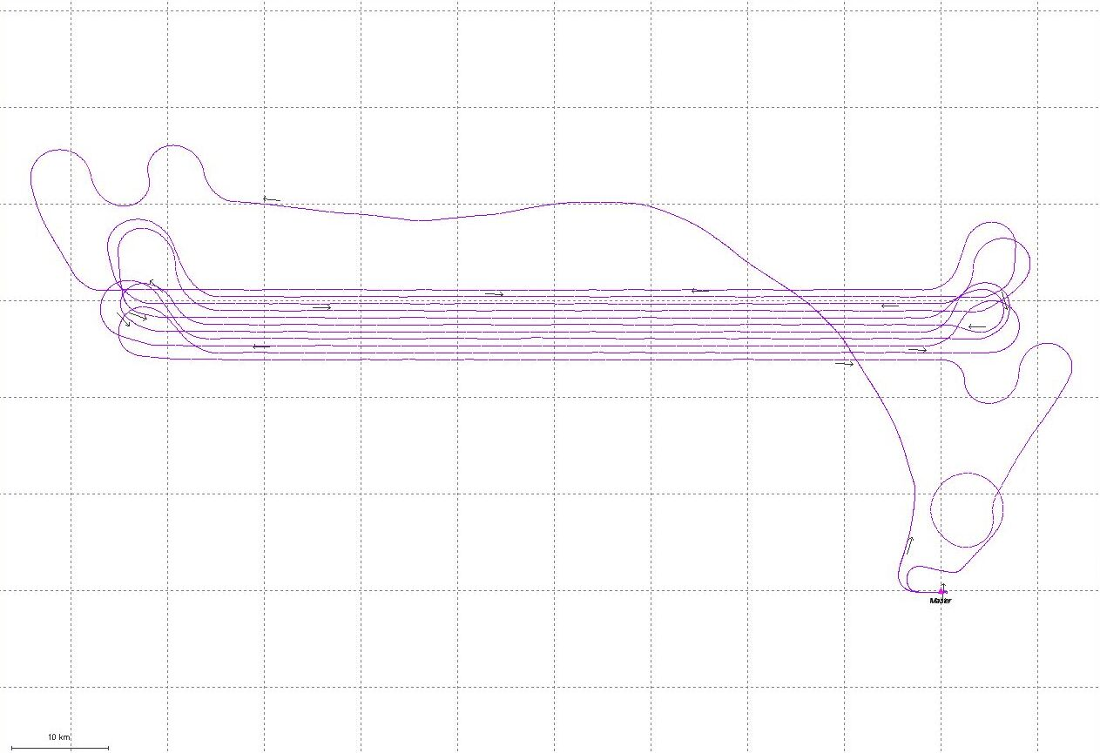
Aircraft Trajectory Plot
Lift 2: 21 October, 2003

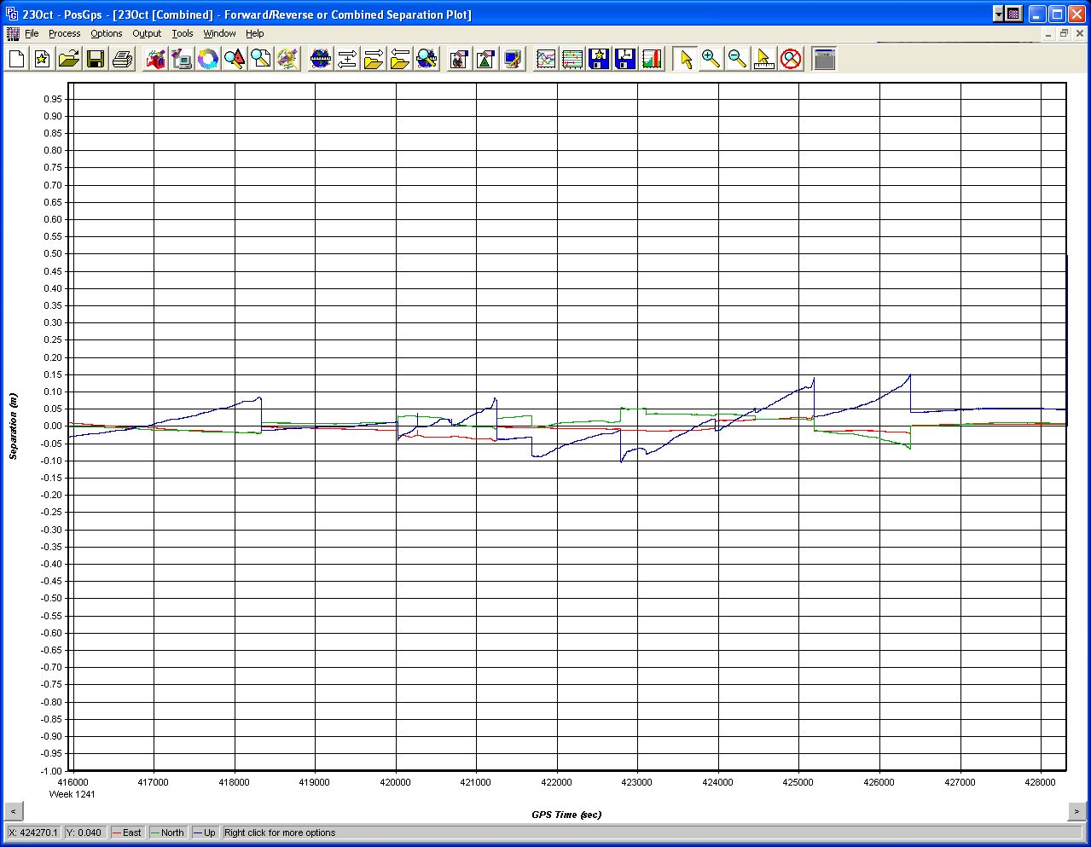
Forward-Reverse Solution Residuals
Lift 3: 23 October. 2003

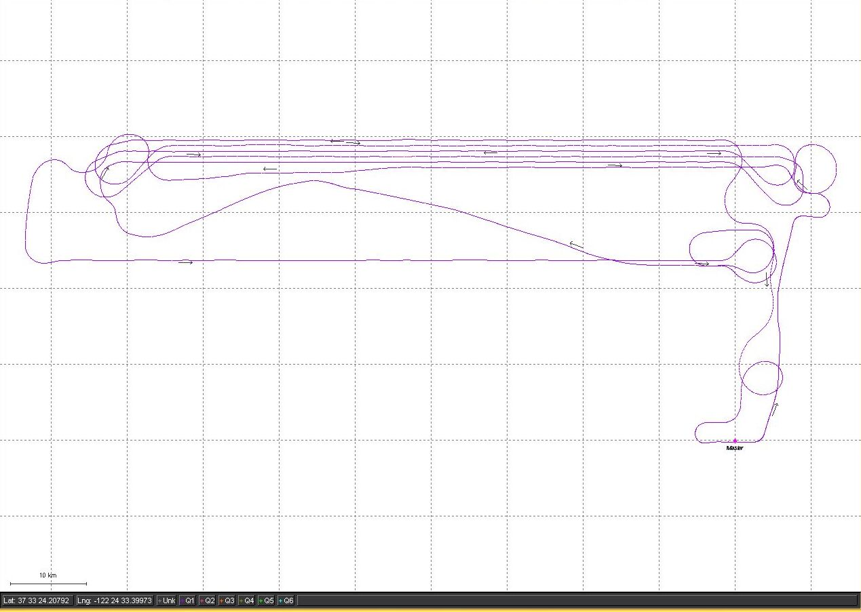
Aircraft Trajectory Plot
Lift 3: 23 October. 2003

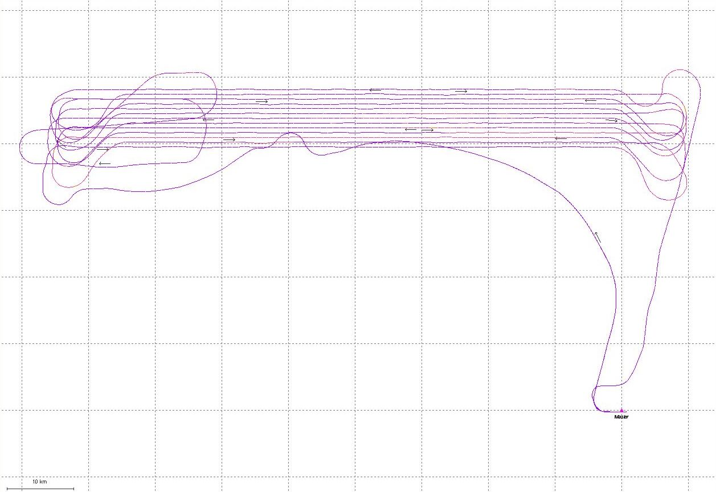
Aircraft Trajectory Plot
Lift 4: 24 October. 2003
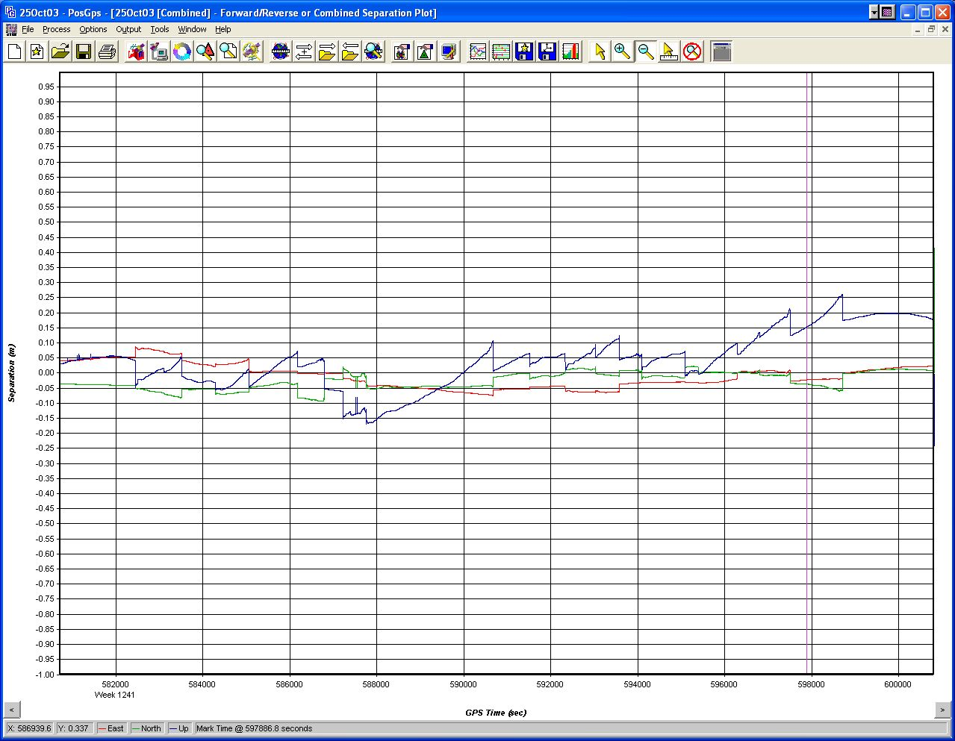
Forward-Reverse Solution Residuals
Lift 5: 25 October. 2003

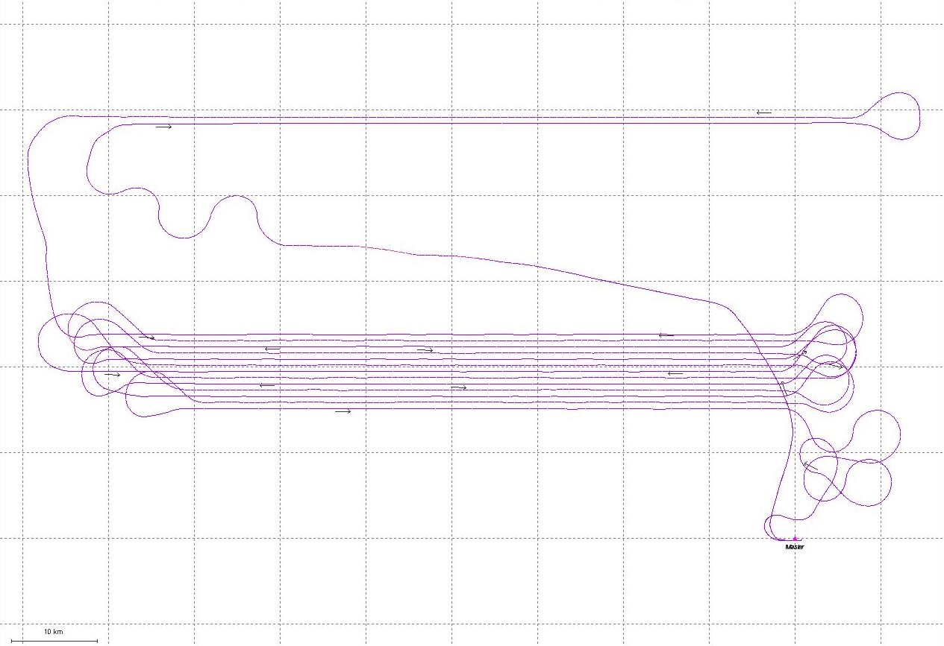
Aircraft Trajectory Plot
Lift 5: 25 October. 2003
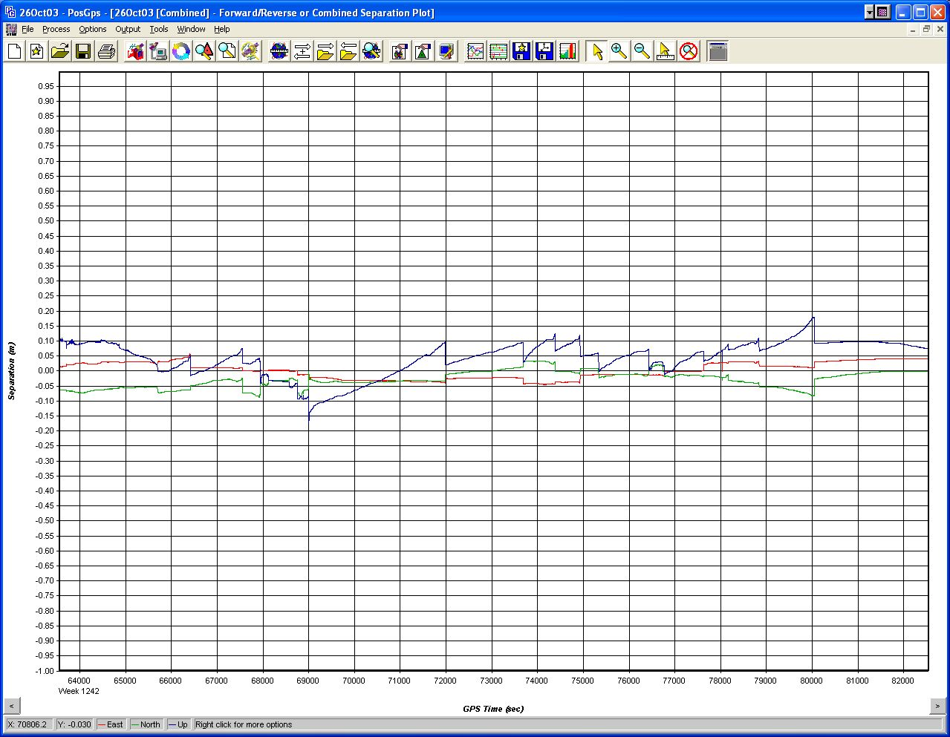
Forward-Reverse Solution Residuals
Lift 6: 26 October. 2003

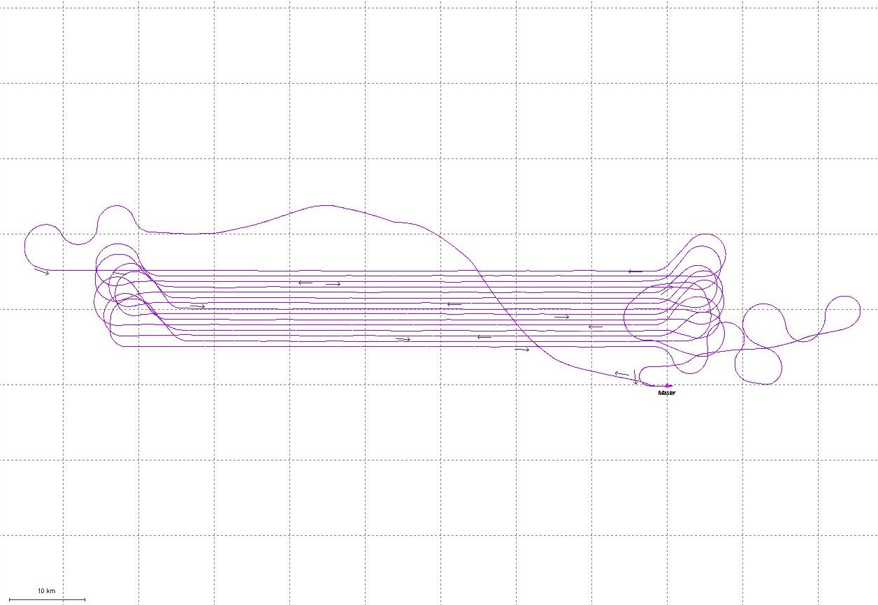
Aircraft Trajectory Plot
Lift 6: 26 October. 2003
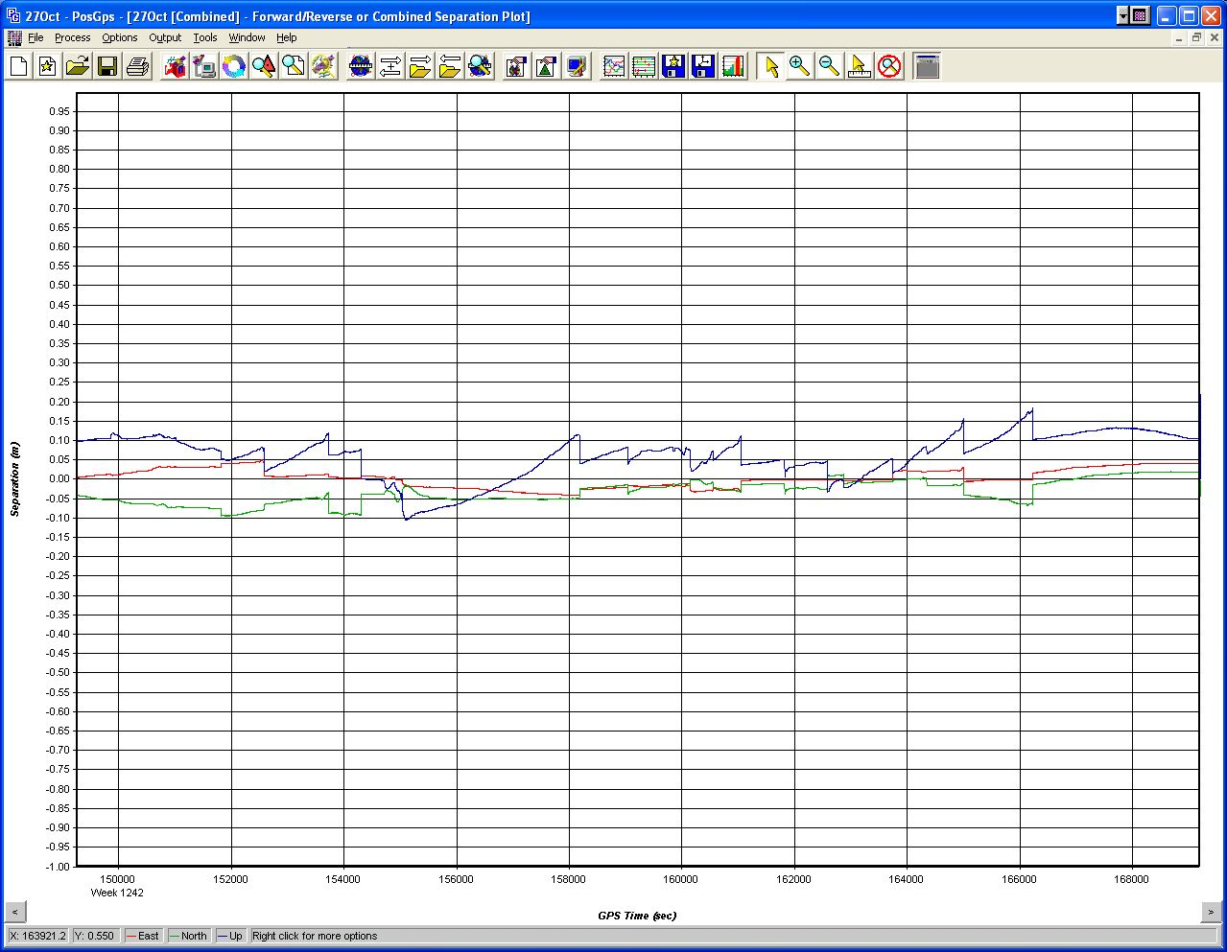
Forward-Reverse Solution Residuals
Lift 7: 27 October. 2003

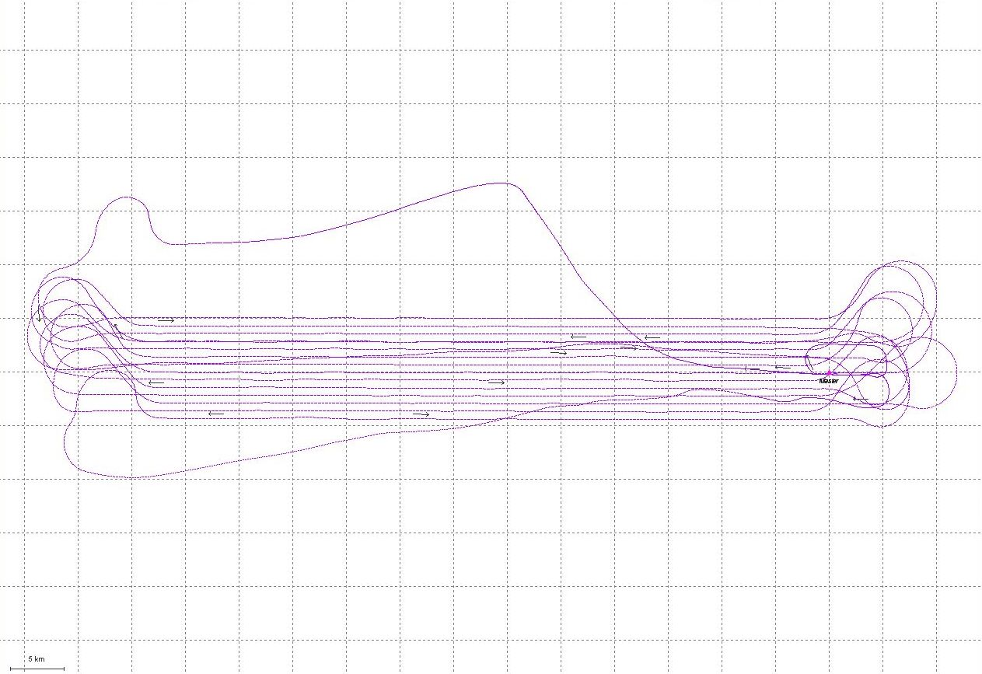
Aircraft Trajectory Plot
Lift 7: 27 October. 2003
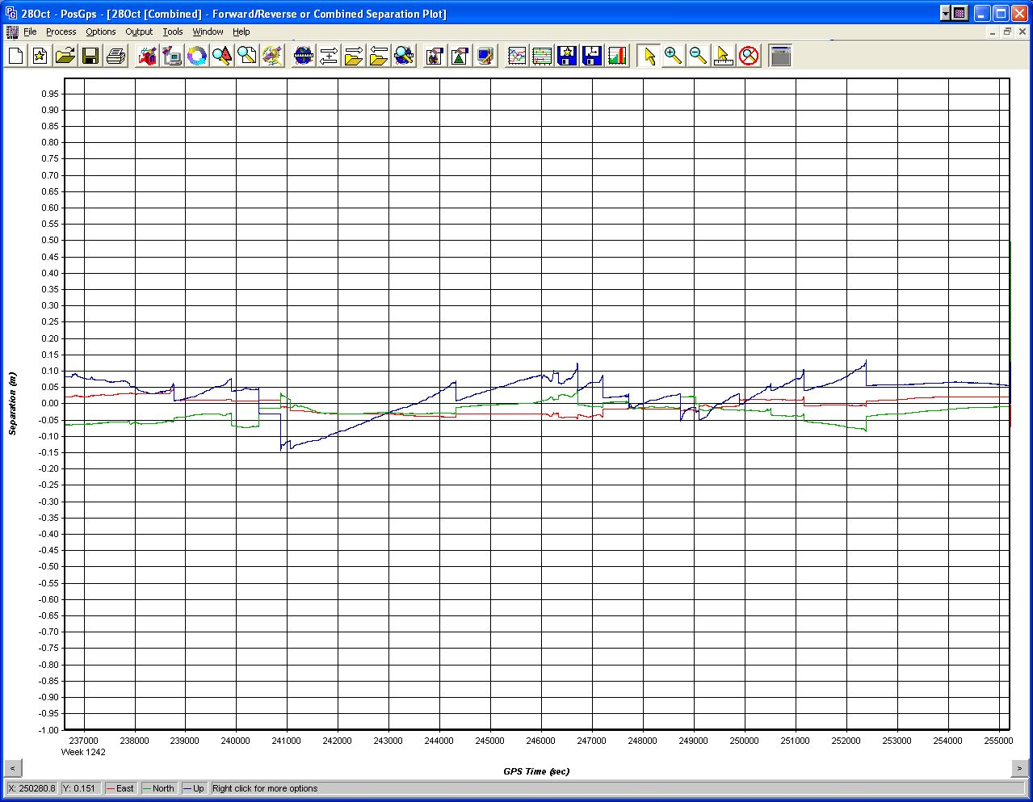
Forward-Reverse Solution Residuals
Lift 8: 28 October. 2003

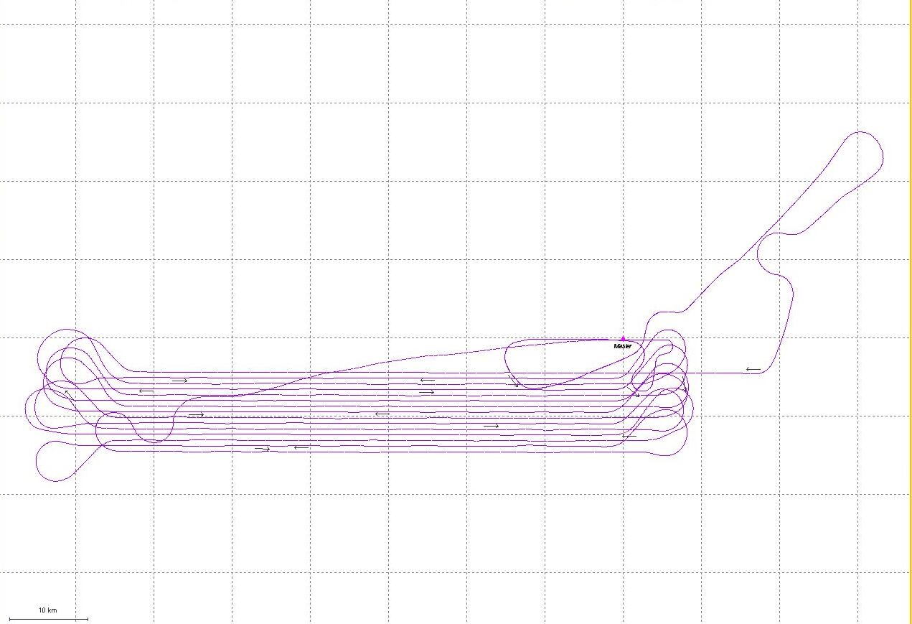
Aircraft Trajectory Plot
Lift 8: 28 October. 2003

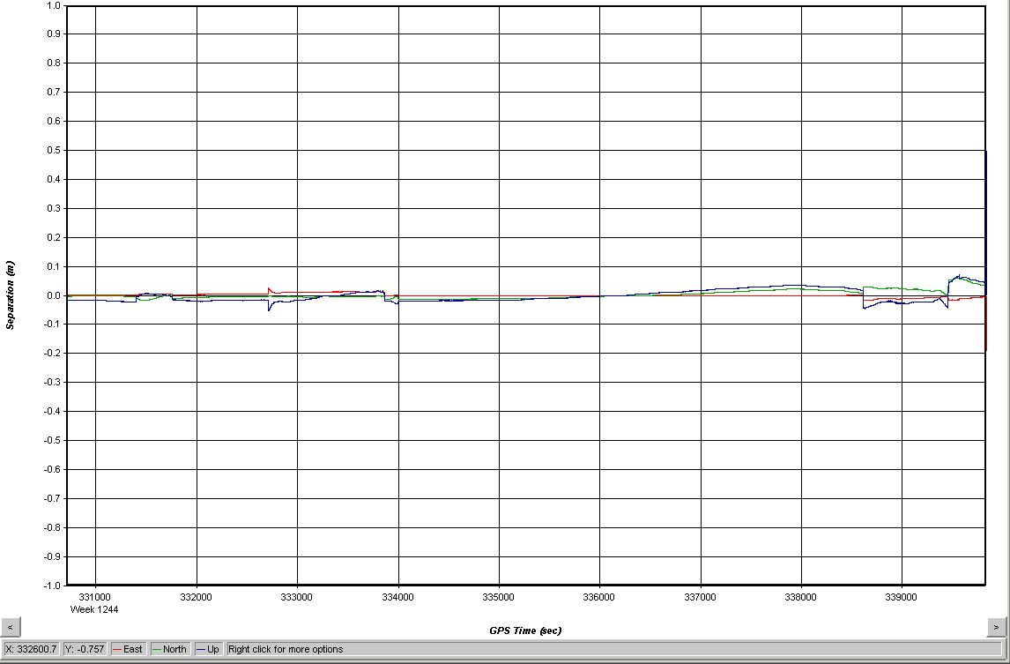
Forward-Reverse Solution Residuals
Lift 9: 12 November 2003

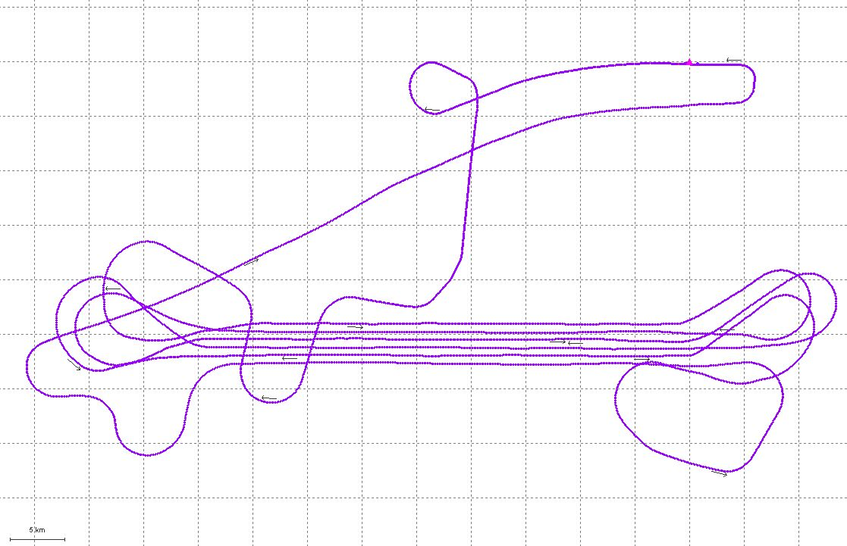
Aircraft Trajectory Plot
Lift 9: 12 November 2003
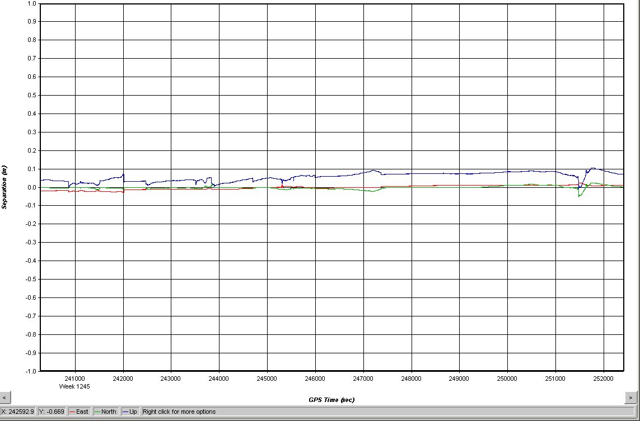
Forward-Reverse Solution Residuals
Lift 10: 18 November 2003

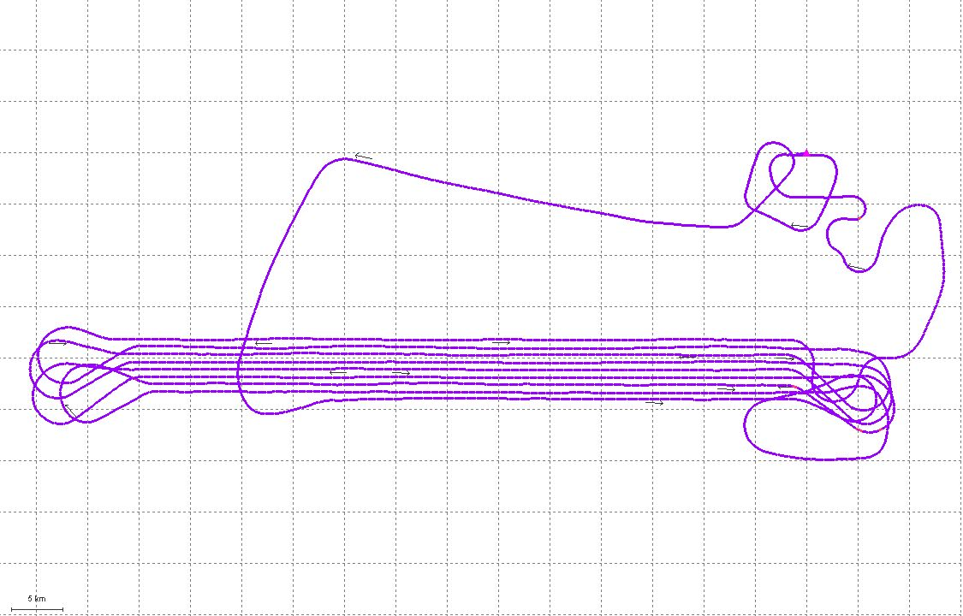
Aircraft Trajectory Plot
Lift 10: 18 November 2003
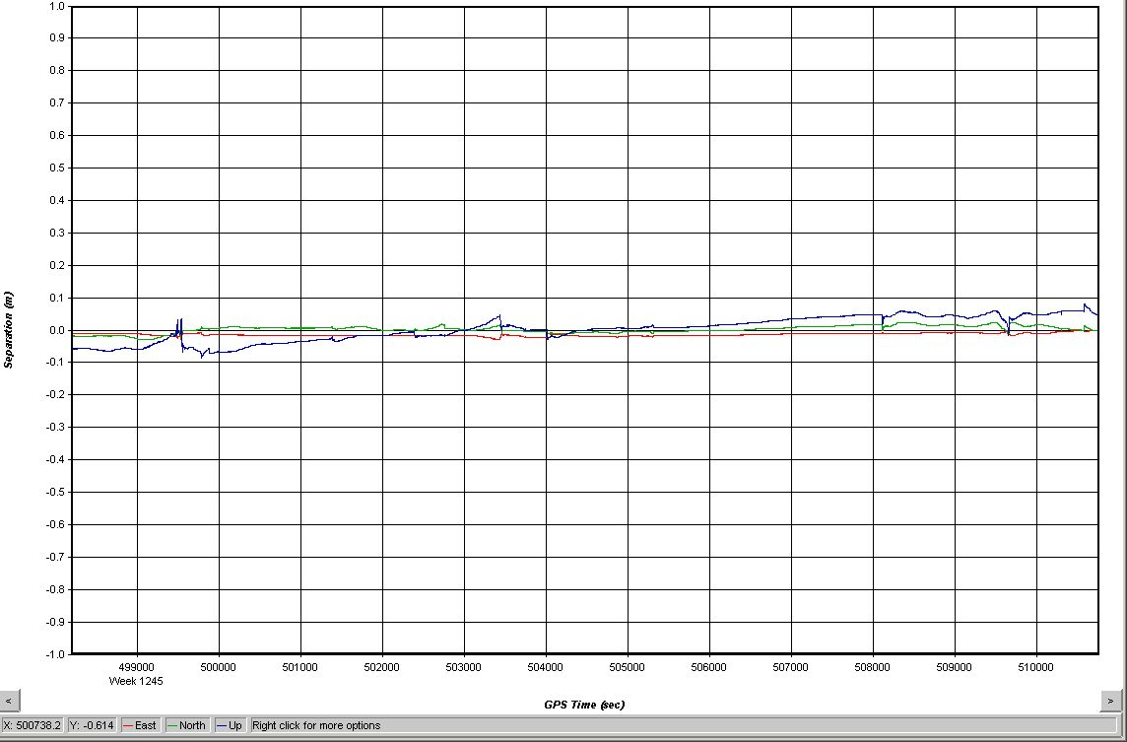
Forward-Reverse Solution Residuals
Lift 11: 21 November 2003

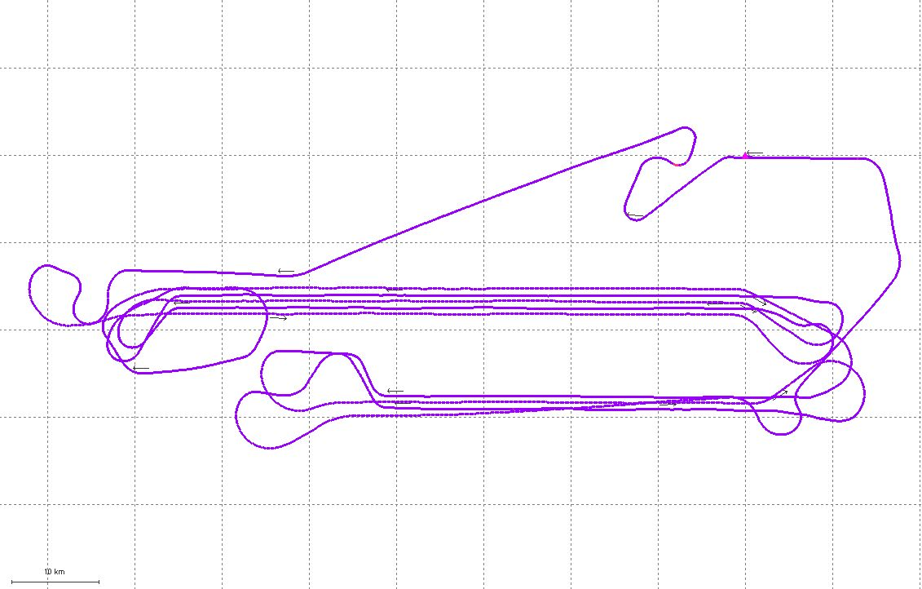
Aircraft Trajectory Plot
Lift 11: 21 November 2003
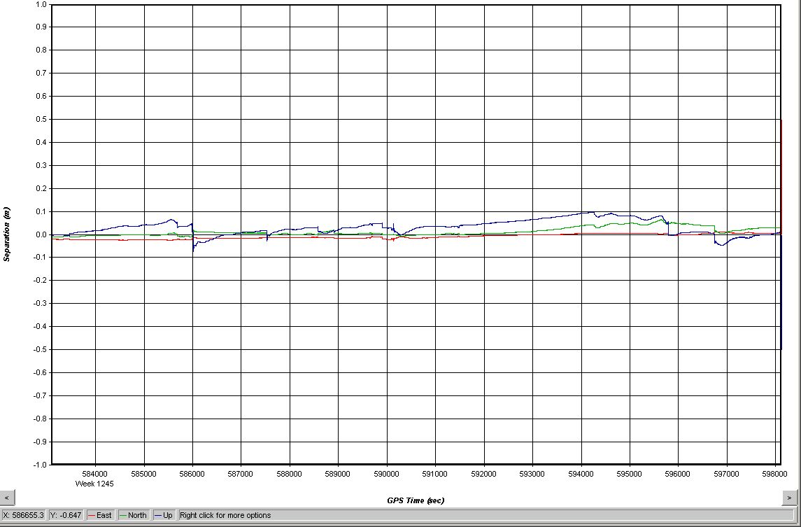
Forward-Reverse Solution Residuals
Lift 12: 22 November 2003

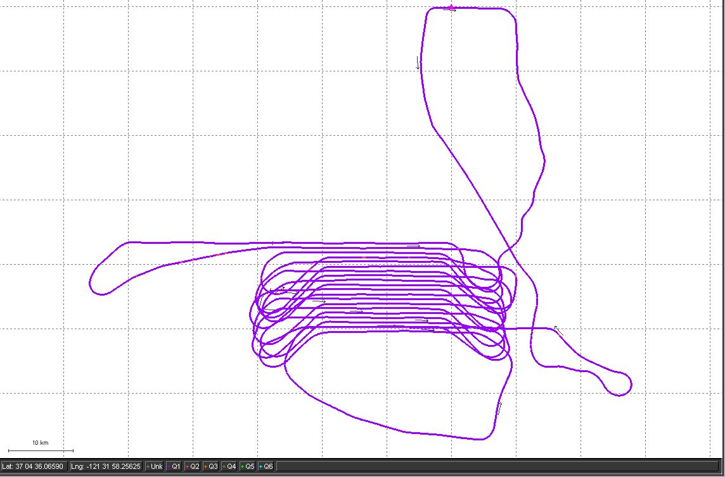
Aircraft Trajectory Plot
Lift 12: 22 November 2003
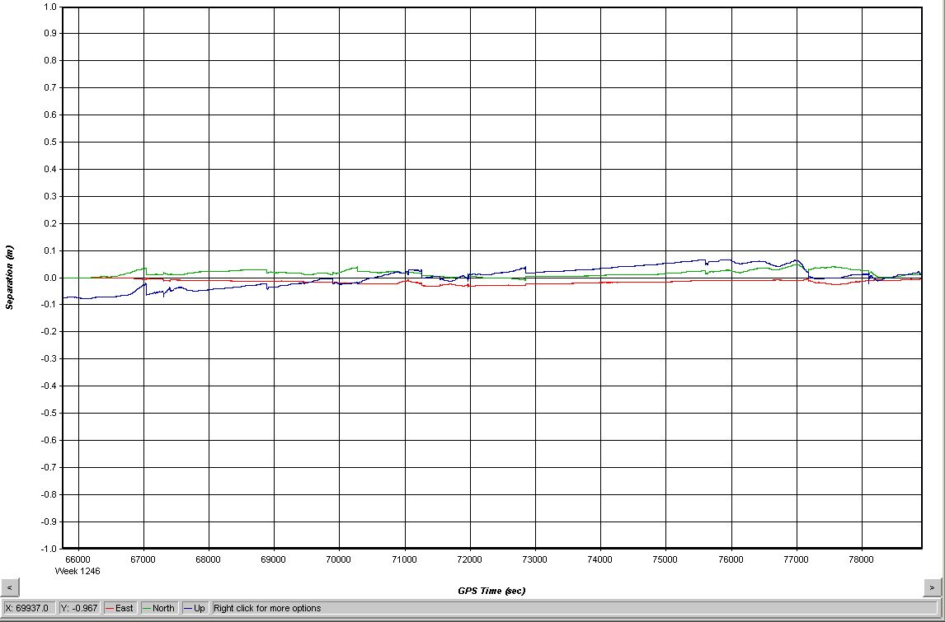
Forward-Reverse Solution Residuals
Lift 13: 23 November 2003

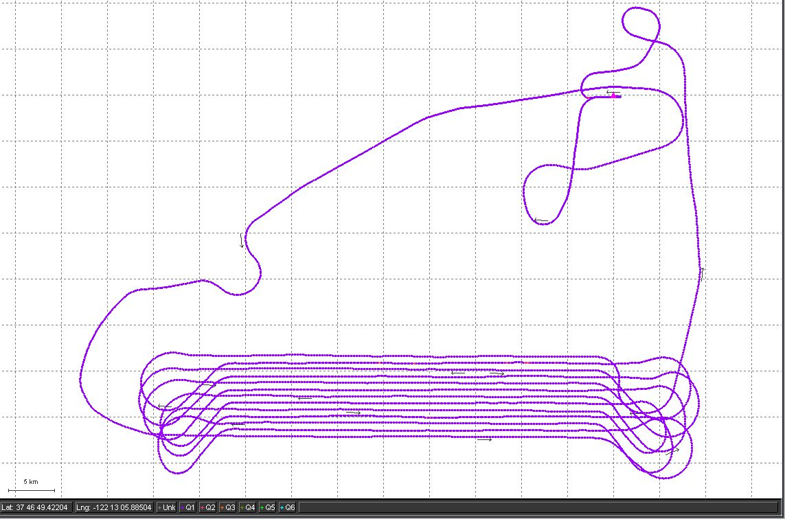
Aircraft Trajectory Plot
Lift 13: 23 November 2003
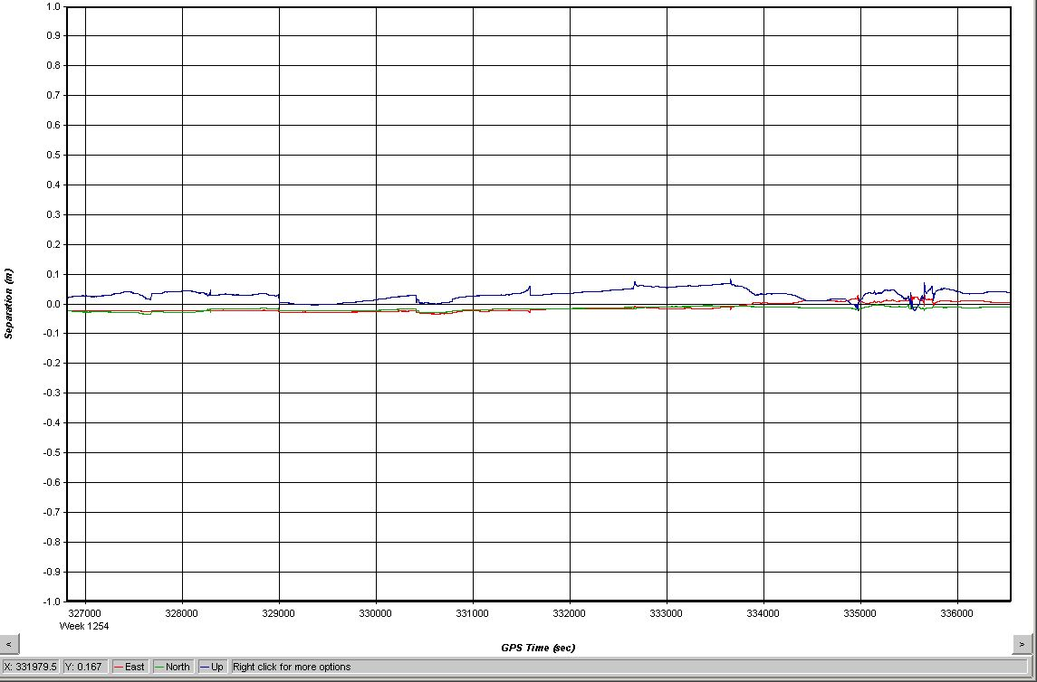
Forward-Reverse Solution Residuals
Lift 14: 21 January 2004

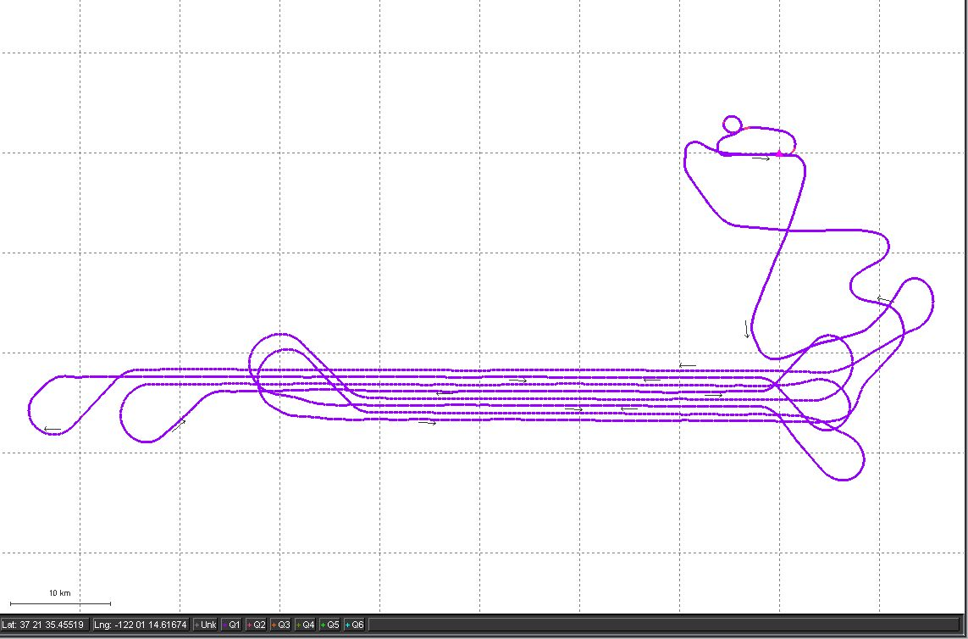
Aircraft Trajectory Plot
Lift 14: 21 January 2004
NGS Datasheet

The NGS Data SheetSee file dsdata.txt for more information about the datasheet.DATABASE = Sybase ,PROGRAM = datasheet, VERSION = 6.89
1 National Geodetic Survey, Retrieval Date = OCTOBER 24, 2003
AC6328 ***********************************************************************
AC6328 PACS - This is a Primary Airport Control Station.
AC6328 DESIGNATION - TOM L
AC6328 PID - AC6328
AC6328 STATE/COUNTY- CA/ALAMEDA
AC6328 USGS QUAD - LIVERMORE (1980)
AC6328
AC6328 *CURRENT SURVEY CONTROL
AC6328 ___________________________________________________________________
AC6328* NAD 83(1998)- 37 41 45.66198(N) 121 49 08.94549(W) ADJUSTED
AC6328* NAVD 88 - 117.98 (meters) 387.1 (feet) GPS OBS
AC6328 ___________________________________________________________________
AC6328 EPOCH DATE - 1998.50
AC6328 X - -2,664,247.892 (meters) COMP
AC6328 Y - -4,293,786.627 (meters) COMP
AC6328 Z - 3,878,853.808 (meters) COMP
AC6328 LAPLACE CORR- 2.69 (seconds) DEFLEC99
AC6328 ELLIP HEIGHT- 85.72 (meters) (04/24/01) GPS OBS
AC6328 GEOID HEIGHT- -32.21 (meters) GEOID99
AC6328
AC6328 HORZ ORDER - B
AC6328 ELLP ORDER - SECOND CLASS I
AC6328
AC6328.This mark is at Livermore Municipal Airport (LVK)
AC6328
AC6328.The horizontal coordinates were established by GPS observations
AC6328.and adjusted by the National Geodetic Survey in April 2001.
AC6328.This is a SPECIAL STATUS position. See SPECIAL STATUS under the
AC6328.DATUM ITEM on the data sheet items page.
AC6328.The horizontal coordinates are valid at the epoch date displayed above.
AC6328.The epoch date for horizontal control is a decimal equivalence
AC6328.of Year/Month/Day.
AC6328
AC6328.The orthometric height was determined by GPS observations and a
AC6328.high-resolution geoid model.
AC6328
AC6328.GPS derived orthometric heights for airport stations designated as
AC6328.PACS or SACS are published to 2 decimal places. This maintains
AC6328.centimeter relative accuracy between the PACS and SACS. It does
AC6328.not indicate centimeter accuracy relative to other marks which are
AC6328.part of the NAVD 88 network.
AC6328
AC6328.Photographs are available for this station.
AC6328
AC6328.The X, Y, and Z were computed from the position and the ellipsoidal ht.
AC6328
AC6328.The Laplace correction was computed from DEFLEC99 derived deflections.
AC6328
AC6328.The ellipsoidal height was determined by GPS observations
AC6328.and is referenced to NAD 83.
AC6328
AC6328.The geoid height was determined by GEOID99.
AC6328
AC6328; North East Units Scale Converg.
AC6328;SPC CA 3 - 633,554.806 1,883,671.083 MT 0.99992964 -0 48 27.5
AC6328;SPC CA 3 - 2,078,587.73 6,180,010.88 sFT 0.99992964 -0 48 27.5
AC6328;UTM 10 - 4,172,744.395 604,103.707 MT 0.99973349 +0 43 19.6
AC6328
AC6328|---------------------------------------------------------------------|
AC6328| PID Reference Object Distance Geod. Az |
AC6328| dddmmss.s |
AC6328| AC6327 ARP LVK 164.343 METERS 15034 |
AC6328|---------------------------------------------------------------------|
AC6328
AC6328 SUPERSEDED SURVEY CONTROL
AC6328
AC6328 NAD 83(1992)- 37 41 45.66057(N) 121 49 08.94280(W) AD(1996.35) 1
AC6328 ELLIP H (02/18/97) 85.69 (m) GP(1996.35) 3 1
AC6328
AC6328.Superseded values are not recommended for survey control.
AC6328.NGS no longer adjusts projects to the NAD 27 or NGVD 29 datums.
AC6328.See file dsdata.txt to determine how the superseded data were derived.
AC6328
AC6328_U.S. NATIONAL GRID SPATIAL ADDRESS: 10SFG0410472744(NAD 83)
AC6328_MARKER: DH = HORIZONTAL CONTROL DISK
AC6328_SETTING: 35 = HELOCOPTER PAD
AC6328_STAMPING: TOM L 1996
AC6328_MARK LOGO: NGS
AC6328_MAGNETIC: N = NO MAGNETIC MATERIAL
AC6328_STABILITY: B = PROBABLY HOLD POSITION/ELEVATION WELL
AC6328_SATELLITE: THE SITE LOCATION WAS REPORTED AS SUITABLE FOR
AC6328+SATELLITE: SATELLITE OBSERVATIONS - April 04, 2003
AC6328
AC6328 HISTORY - Date Condition Report By
AC6328 HISTORY - 19960101 MONUMENTED NGS
AC6328 HISTORY - 20001207 GOOD NGS
AC6328 HISTORY - 20010410 GOOD NGS
AC6328 HISTORY - 20030404 GOOD NGS
AC6328
AC6328 STATION DESCRIPTION
AC6328
AC6328'DESCRIBED BY NATIONAL GEODETIC SURVEY 1996 (MLA)
AC6328'THE STATION IS LOCATED AT THE LIVERMORE MUNICIPAL AIRPORT 3.0 MI (4.8
AC6328'KM) NORTHWEST OF LIVERMORE, CA AND ABOUT 5.5 MI (8.9 KM) EAST OF THE
AC6328'INTERSECTION OF INTERSTATES 680 AND 580 IN DUBLIN, CA. OWNERSHIP --
AC6328'CITY OF LIVERMORE CONTACT TOM LITTLE, AIRPORT MANAGER, AT (510)
AC6328'373-5280 FOR ACCESS. TO REACH THE STATION FROM THE INTERSECTION OF
AC6328'INTERSTATE 580 AND INTERSTATE 680 IN DUBLIN PROCEED EAST ON INTERSTATE
AC6328'580 FOR APPROXIMATELY 5.5 MI (8.9 KM) TO AN EXIT RIGHT FOR AIRWAY
AC6328'BLVD. TAKE EXIT AND PROCEED EASTERLY FOR .25 MI (0.40 KM) TO STOP
AC6328'SIGN AND INTERSECTION WITH AIRWAY BLVD. TURN RIGHT ONTO AIRWAY BLVD
AC6328'AND PROCEED SOUTH FOR .2 MI (0.3 KM) TO A STOP SIGN, AIRPORT, AND ROAD
AC6328'RIGHT - TERMINAL CIRCLE. TURN RIGHT AND PROCEED FOR .05 MI (0.08 KM)
AC6328'TO THE DAN LEE AIR TERMINAL BUILDING ON THE LEFT AND THE STATION IN
AC6328'THE CENTER OF AN ABANDONED CONCRETE HELIPAD WEST OF THE TERMINAL
AC6328'BUILDING. THE STATION IS 26.0 M (85.3 FT) SOUTHEAST OF THE CENTERLINE
AC6328'OF TERMINAL CIRCLE, 19.0 M (62.3 FT) SOUTHWEST OF THE NORTHWEST CORNER
AC6328'OF THE TERMINAL BUILDING, AND IS SET IN A DRILL HOLE IN THE CENTER OF
AC6328'A 6.0 M (19.7 FT) ACROSS CONCRETE HELIPAD WITH A SIDEWALK LEADING TO
AC6328'THE AIRFIELD SIDE OF THE TERMINAL BUILDING. THE STATION IS A STANDARD
AC6328'NGS HORIZONTAL STATION DISK STAMPED --TOM L 1996-- AND SET IN A DRILL
AC6328'HOLE IN A CONCRETE HELIPAD.
AC6328
AC6328 STATION RECOVERY (2000)
AC6328
AC6328'RECOVERY NOTE BY NATIONAL GEODETIC SURVEY 2000 (BW)
AC6328'RECOVERED AS DESCRIBED. THIS STATION HAS BEEN DESIGNATED AS THE
AC6328'PRIMARY AIRPORT CONTROL STATION (PACS).
AC6328'
AC6328'
AC6328
AC6328 STATION RECOVERY (2001)
AC6328
AC6328'RECOVERY NOTE BY NATIONAL GEODETIC SURVEY 2001 (GFS)
AC6328'RECOVERED AS DESCRIBED. THIS STATION HAS BEEN DESIGNATED AS THE
AC6328'PRIMARY AIRPORT CONTROL STATION (PACS).
AC6328'
AC6328'
AC6328
AC6328 STATION RECOVERY (2003)
AC6328
AC6328'RECOVERY NOTE BY NATIONAL GEODETIC SURVEY 2003 (SER)
AC6328'RECOVERED AS DESCRIBED.
AC6328'

